Utility Wind Step 2: Nacelle Module

Table of Contents

Descriptive Information 2

Descriptive Text of Value Chain Step 2

Relevant Figures (if any) 2

[For operations value chain step of natural gas and T&D only (unless we get lucky): Emissions of GHGs and possibly criteria air pollutants] 2

References 2

Y=Innovative Outcomes 2

Direction and rate of technological change (text) 2

Illustrations 3

Data on Quantity, Cost, Quality 3

Tech Trend Table that would let someone else build a learning curve/experience curve 3

Additional text on quantity cost quality data (e.g., widget cost: XX (reference); widget beauty: YY (reference) 3

References 3

X= Strategic Conditions 3

Porter's 5 Forces diagram of this value chain step (governance, related industries relevant) 3

Market structure text (and maybe accompanying illustration) 4

Overview of Geography (as it relates to imperfect competition) 4

Overview of Governance (as it related to imperfect competition) 4

Illustrations if relevant (e.g., time-series of M&A -- see wind example) 4

Quantitative treatment of imperfect competition w/ accompanying descriptive text 4

FFCR with NAICS codes 4

HHI if possible - either we calculate based on table below or we cite somebody else's calculation 5

Firm Economic Data Talbe 5

References 5

X = Knowledge Conditions 5

# Descriptive Information

## Descriptive Text of Value Chain Step

|  |
| --- |
| *(1) For dummies (engineering/business). What is the object and/or business at this value chain step? How does the business work in this value chain step. [A couple of sentences]. (2) This step in the value chain is covered by "..." (6-digit NAICS code)" and Y standards/FTC codes etc...(think Joanna Lewis and Global Trade Alerts)* |

The box-like nacelle module is considered as the heart of a wind turbine which sits on top of the tower and is connected to the rotor. Nacelle is usually made of fiberglass and houses the most important generating component of a wind turbine, a drivetrain. The drivetrain is responsible for converting the low speed incoming rotation to high speed rotation that the generator needs to begin producing electricity, and it is typically composed of the rotor shaft, gearbox and generator. In addition, the nacelle also contains a yaw drive system that ensures the rotor is always facing into the wind and a control system that adjust the pitch angle of the blades under different wind speeds to prevent structural damages on the wind turbine. (Serrano-González and Lacal-Arántegui, 2016)

The plants that produce nacelles are primarily assembly facilities. There are four components of nacelle production: (1) nacelle structural assembly, (2) drivetrain assembly, (3) nacelle electrical assembly, and (4) yaw assembly. According to the cost report by National Renewable Energy Laboratory (NREL), the nacelle module accounts for approximately 36% of the one-shore wind power project cost in 2015.2

Nacelle components are either produced in-house of by outside suppliers to the specifications of the nacelle original equipment manufacturer (OEM) and then assembled at the nacelle plant. Many foreign OEMs are localizing nacelle production in the United States to take advantage of the growing market and reduce transportation costs and logistical challenges.

GE Renewable Energy, Siemens, Vestas and Phoenix are the four major wind turbine nacelle assembly manufacturers with production facilities located in the United States. As in 2016, these major nacelle assembly facilities are capable of producing approximately 11,700 MW of turbine nacelle annually. 1

The drivetrain components that go into the nacelle module are included in *“Speed Changer, Industrial High-Speed Drive, and Gear Manufacturing”* (NAICS 333612) and *“Mechanical Power Transmission Equipment Manufacturing”* (NAICS 333613). The overall nacelle assembly is part of *“Turbine and Turbine Generator Set Units Manufacturing”* (NAICS 333611).[1] As reported in the 2012 Economic Census, there are 183 establishments, 36,955 employees covered under this industry with a value of shipments of 16.9 billion dollars. However, even at their most disaggregated level (six-digit code), each of the NAICS code covers a range of components, products, and services beyond those specific to nacelle component manufacturing and nacelle assembly.

## Relevant Figures (if any)

|  |
| --- |
| *Don't go crazy on this. And look first for stock/DOE images (i.e., no copyright issue)* |

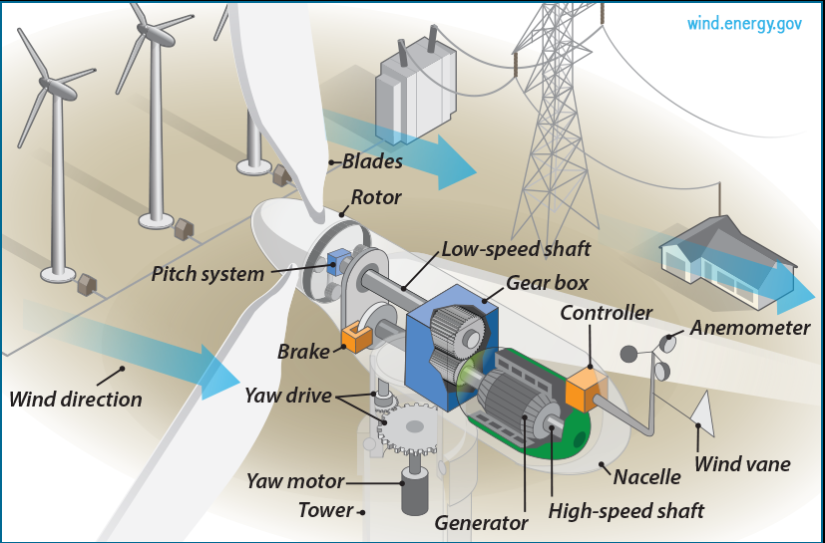

Source: <https://energy.gov/eere/wind/inside-wind-turbine-0>

Figure 1: Win Turbine Anatomy

|  |
| --- |
| [For operations value chain step of natural gas and T&D only (unless we get lucky): Emissions of GHGs and possibly criteria air pollutants] For the O&M step of natural gas: negative externality GHGs/criteria pollutants (one sentence embedded link to EPA or EIA) |

## References

|  |
| --- |
| *Only what we cite for text above and figures. Expansion of this is a nice-to-have to build on later* |

1. National Renewable Energy Laboratory. *2015 Cost of Wind Energy Review*. 2017. https://www.nrel.gov/docs/fy17osti/66861.pdf.

2. American Wind Energy Association. *U.S. Wind Industry Annual Market Report Year Ending 2016*. 2016. https://www.awea.org/2016-market-reports.

3. United States Census Bureau. 2012 North American Industry Classification System (NAICS) Definition. https://www.census.gov/cgi-bin/sssd/naics/naicsrch?chart=2012.

# Y=Innovative Outcomes

## Direction and rate of technological change (text)

|  |
| --- |
| *(1) The quality factors (i.e., performance attributes and/or cost) that guide this value chain step are ... (= direction of tech change; e.g., the blades are getting longer and lighter and more resilient (the reason for this is to support the increasing size of turbines, but this gets covered on the operations tab)). (2) Innovation/competition has resulted in a (dominant design or competing alternative designs). (3) Describe design(s). (4) Maybe (nice to have) something on rate of tech change (e.g., mature technology). (5) Maybe (nice to have) how industry is pushing to improve the technology (think incremental innovation or push to more radical innovation). (6) ... THIS WILL INCLUDE REFERENCE TO THE PREVIOUS Dominant design overview text. incremental innovation trends - how is industry pushing to improve the technology now. New developments (qualitative information on potentially emerging technologies, niche technologies – things that speak to the threat to the dominant design posed by substitutes and/or new entrants)* |

The driving forces for innovation in nacelle design is mostly focused on: (1) maximizing efficiency, especially when operating at partial loads, (2) improving reliability, such as the development of direct drive concept, and (3) reducing cost through radical concept changes or more integrated design.

There are three major types of drivetrain systems: (1) geared wind turbine with double fed induction generator, (2) gearless or direct drive configuration with a synchronous generator directly attached to the main shaft and a full-power converter, and (3) hybrid configuration equipped with a gearbox and a generator coupled with a full-power converter. (Serrano-González and Lacal-Arántegui 2016) (Hansen *et al.* 2004)

One particular type of geared high-speed wind turbine with doubly fed induction generator (DFIG) configuration is currently dominating the wind industry in the United States. Under the DFIG configuration, the current in the electric generator’s rotor is controlled by a power converter; hence, electrical losses are lower and the response to grid requirements is enhanced. (Serrano-González and Lacal-Arántegui 2016).

In recent years, the gearless or direct drive configuration has become more prevalent in parts of the world because of the reliability improvement from eliminating gearbox with components that tend to have higher failure rate, such as gearbox bearings. There are two main types of gearless or direct drive wind turbine, the first type is based on electrically excited synchronous generators (EESGs) which is developed by German-based Enercon, and the second type is based on permanent magnet synchronous generators (PMSGs) which is developed by Chinese-based Goldwind. Generally, direct drive wind turbines with PMSGs are more efficient and robust than the traditional DFIG and EESGs. However, the rare earths needed to manufacture permanent magnets have experienced substantial cost increase in the past five years, which lead to a decrease in deployment of direct drive wind turbine PMSGs, especially in Europe and the United States. As a result, the hybrid configuration – gearbox-equipped wind turbine with a full converter and squirrel cage induction generator (SCIG) – has become a compromise solution and is gaining more market share in the United States.

Typically, turbine configuration is strongly related to rated power; as the rated power differs, the most suitable turbine configuration of that wind turbine would be different. The traditional geared wind turbine with DFIG is the most popular configuration for turbines below 2 MW. In the range of 2-3 MW, hybrid configuration equipped with a gearbox and a generator coupled with a full-power converter is the preferred choice.

**References:**

(Serrano-González and Lacal-Arántegui, 2016)

<http://markets.businessinsider.com/news/stocks/Wind-Gearbox-and-Direct-Drive-Update-2017-Global-Market-Size-Competitive-Landscape-and-Key-Country-Analysis-to-2021-1002345447>

Innovation in Wind Turbine Design – Peter Jamieson (2011)

## Illustrations

|  |
| --- |
| *Dominant design overview image (eg flow diagram, photo)* |

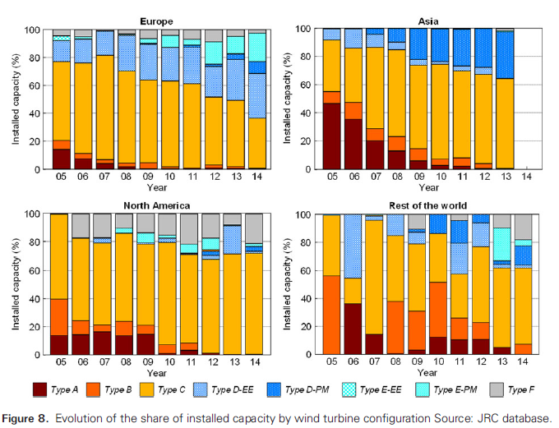

Figure 2: Shares of Drive Train Configuration by Region

Source: (Serrano-González and Lacal-Arántegui, 2016)

Note: Type A, B and C are geared high-speed wind turbines, in particular, type C represents the DFIG configuration. Type D-EE and type D-PM are the direct drive with EESG and PMSG, respectively. Type E-EE and type E-PM are the hybrid configuration with EESG and PMSG, respectively. Type F is the hybrid configuration with SCIG.

## Data on Quantity, Cost, Quality

### Tech Trend Table that would let someone else build a learning curve/experience curve

|  |  |  |  |  |  |  |  |  |
| --- | --- | --- | --- | --- | --- | --- | --- | --- |
| *Only exists if we have year and one or more of quantity cost quality*  ***Table Properties:***   |  |  | | --- | --- | | Year | If no time-series avaialble, do one row with the year either current or tied to a specific reference | | Quantity | i) Quantity of relevance (e.g., shipments, # of projects/installations, power generated, etc.) - (to enable learning curve calcs) | | Cost | ii) Cost (to enable learning curve calcs) | | Quality/attributes |  | |

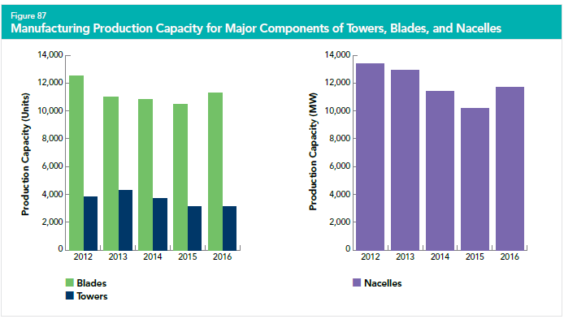

Source: AWEA 2016 Wind Industry Annual Market Report

Figure 3: Manufacturing Production Capacity for Major Wind Turbine Components

### Additional text on quantity cost quality data (e.g., widget cost: XX (reference); widget beauty: YY (reference)

|  |
| --- |
| *Only exists if one of the three (quantity, cost, quality) has a year and the others don't* |

*“During the forecast period, the average cost of a gearbox unit is expected to decline due to economies of scale and maturity of wind gearbox technology. As a result, the value of the global wind gearbox market is expected to decline at a negative CAGR of 2.5% between 2016 and 2021. The market is dominated by independent wind gearbox suppliers, namely China High Speed Transmission Equipment, ZF Wind, and Winergy.*

*Direct-drive wind turbines, powered by direct-drive generators with no gearbox requirements, improve the performance and reliability over conventional wind turbines. The share of global wind turbine installations accounted for by direct-drive turbines increased from around 24.9% in 2011 to 25.2% in 2016 and is expected to increase another 7% during the forecast period (2017-2021) to reach 32.2% in 2021.”*

<http://markets.businessinsider.com/news/stocks/Wind-Gearbox-and-Direct-Drive-Update-2017-Global-Market-Size-Competitive-Landscape-and-Key-Country-Analysis-to-2021-1002345447>

## References

# X= Strategic Conditions

## Porter's 5 Forces diagram of this value chain step (governance, related industries relevant)

|  |
| --- |
| *(modified/modeled on ibis world pic; cool if we could do with pie charts on supply and customer steps in vc based on 3 underlying spreadsheets of data.* |

## Market structure text (and maybe accompanying illustration)

|  |
| --- |
| *Current! Competitive landscape re: this value chain step only!! Relevant topics include: major firms, firm size, m&A (entry/exit), information on concentration and competition, vertical integration, barriers to entry (e.g., capital requirements, hard to get finance, lack of/need for highly skilled labor, infrastructure -- like only so many pipelines to sell aggregated natural gas into), make/buy/ally that underlies vertical integration, new competitors, current competitor/substitutes. Pull from previous "market snapshots" and "firm text" in spreadsheets.* |

### Overview of Geography (as it relates to imperfect competition)

|  |
| --- |
| *HQs. Global demand? Global supply? Leading firms and geography. How tied to governance.* |

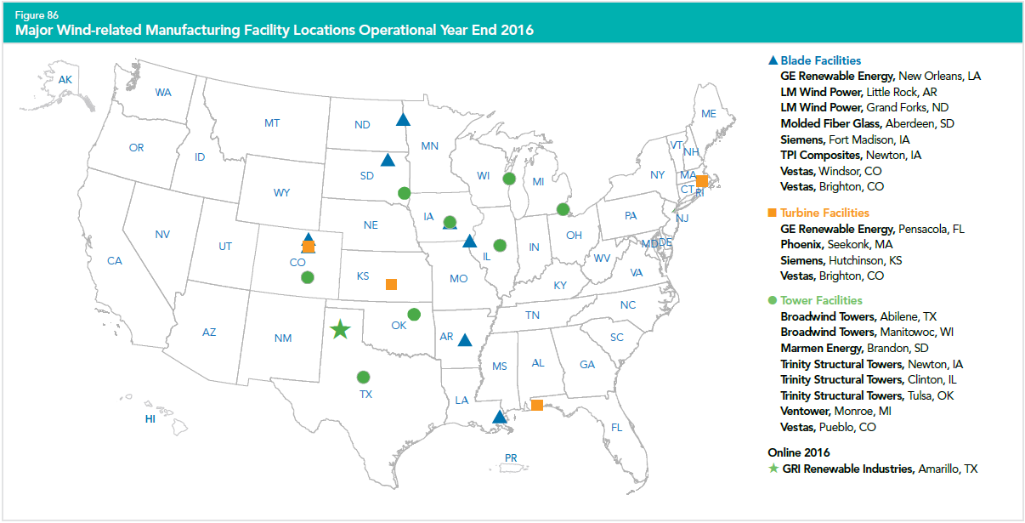

Source: AWEA 2016 Wind Industry Annual Market Report

Figure 4: Map of Major Wind-related Manufacturing Facility Locations in 2016

Table 1: List of Generator Manufacturers in the United States

|  |  |  |  |  |
| --- | --- | --- | --- | --- |
| **Company Name** | **Location** | **Land-based/Offshore** | **Coast** | **Notes** |
| ABB | Bland, VA | Both | Atlantic | Capability exist – but not in the U.S. No current ABB U.S. generator manufacturing facilities. Bland, VA facility currently produces transformers only. |
| Ideal Electric | Mansfield, OH | Both | No | Low & Medium Speed synchronous generators. 4‐pole generators. |
| Ingeteam | Milwaukee, WI | Both | Great Lakes | Capability exists. Current supplier of  generators and transformers for U.S. and  Europe. |
| Swiger Coil Systems | Cleveland, OH | Both | Great Lakes | All motors and generators are built and tested to OEM designs and specifications |
| TECO-Westinghouse | Round Rock, TX | Both | No | Manufactures double‐fed induction, synchronous, PMDD for 1‐5MW turbines. |

Source: GLWN, U.S. Wind Energy Manufacturing and Supply Chain Competitiveness Analysis (2014)

* Some company information has been modified to reflect their most current operation in the U.S.

** The Schnabel car is a specialized type of long railroad freight car with low gravity center. It is designed to carry heavy and oversized loads (such as heavy‐duty transformers, parts of hydraulic turbines, stators and rotors of generators, columns, frames) that cannot be transported by other cars due to their weight and/or size.

Table 2: List of Gearbox Manufacturers in the United States

|  |  |  |  |  |
| --- | --- | --- | --- | --- |
| **Company Name** | **Location** | **Land-based/Offshore** | **Coast** | **Notes** |
| Horsburgh & Scott | Cleveland, OH | Both | Great Lakes | Capability exists. Experience in contract gearbox assembly and repair for up to 2MW units. Could manufacture gearboxes for 3MW and 5MW with investments to support full manufacturing and serial production. |
| Moventas | Portland, OR | Both | Pacific | Capability exists. Experience in contract gearbox assembly up to 2MW. Investment likely to support full manufacturing and serial production. European facilities produce for 3MW‐10MW units. |
| Winergy Drive Systems Corporation | Elgin, IL | Both | No | Capability exists. Current manufacturer for up to 3MW. Some investment likely to manufacturing 5MW units. |
| ZF Wind Power | Gainesville, GA | Both | No | Capability exists. Current manufacturer for up to 3MW. Some investment likely to manufacturing 5MW units. |

Source: GLWN, U.S. Wind Energy Manufacturing and Supply Chain Competitiveness Analysis (2014).

* Few companies from the original sources have been removed because they ceased operation in the U.S. ** Current suppliers are located in closest proximity to the central U.S. wind turbine OEMs. Gearboxes, even for the 5MW, are transportable by rail and vessel. 5MW weights may present some challenges for long distance truck transport.

Table 3: List of Composite Housing Manufacturers in the United States

|  |  |  |  |  |
| --- | --- | --- | --- | --- |
| **Company Name** | **Location** | **Land-based/Offshore** | **Coast** | **Notes** |
| MFG Alabama | Opp, AL | Both | Gulf | Capability exists. Currently manufactures nacelle housings. Can support both 3MW and 5MW production with minimal investment required. |
| MFG West | Adelanto, CA | Both | Pacific | Capability exists. Currently manufactures nacelle housings. Can support both 3MW and 5MW production with minimal investment required. |
| MFG Composite Systems | Ashtabula, OH | Both | Great Lakes | Capability exists. Currently manufactures spinners. Could manufacture nacelle housings or spinners for 3MW or 5MW but with some investment required. |
| MFG South Dakota | Aberdeen, SD | Both | No | Capability exists. Currently manufactures blades. Could manufacture nacelle housings or spinners for 3MW and 5MW with minimal investment required. |
| MFG Texas | Gainesville, TX | Both | Gulf | Capability exists. Currently manufactures blades. Could manufacture nacelle housings or spinners for 3MW and 5MW with minimal investment required. |
| MFG Union City | Union City, PA | Both | Great Lakes | Capability exists. Could manufacture nacelle housings or spinners for 3MW or 5MW but with some investment required. |

Source: GLWN, U.S. Wind Energy Manufacturing and Supply Chain Competitiveness Analysis (2014)

* Few companies from the original sources have been removed because their current operation status cannot be confirmed.

** Land‐based is well positioned with experienced and qualified suppliers, located within reasonable proximity to current land‐based OEMs, and capable of manufacturing and supplying nacelle housings, spinner covers and nosecones for the 3MW and larger turbines.

### Overview of Governance (as it related to imperfect competition)

|  |
| --- |
| *Reminder: could be international trade, national laws, regional interconnection, state, local; institutions, maybe major laws/regs)* |

### Illustrations if relevant (e.g., time-series of M&A -- see wind example)

|  |
| --- |
| *Reminder: could be international trade, national laws, regional interconnection, state, local; institutions, maybe major laws/regs)* |

## Quantitative treatment of imperfect competition w/ accompanying descriptive text

|  |
| --- |
| (HHI best, FFCR easiest/most consistent) - maybe down to level of 8-12 firms (but if do this, please explain value) |

### FFCR with NAICS codes

|  |
| --- |
| *Needs accompanying text that 6 digit NAICS codes are broader and what FFCR is and how to interpret. The age of this data and what we expect about timing of updated data. Txt with table w NAICS fields (establishments, employees, shipments, number of companies, … [consolidate 2 NAICS code tables]* |

### HHI if possible - either we calculate based on table below or we cite somebody else's calculation

## Firm Economic Data Table

|  |
| --- |
| Current data! (according to data needed for HHI calculations, at least – not sure what data beyond this goes into horizontal merger analysis by antitrust folks) |

|  |  |  |  |  |  |  |
| --- | --- | --- | --- | --- | --- | --- |
| **Firm Name** | **Revenue** | **Quantity of relevance (e.g., shipments, # of projects/installations, power generated, etc.) - (to enable imperfect competition calculations)** | **Market share** | **HQ Location** | **Ticker symbol (if available)** | **Web address of firm annual report** |
| GE Renewable Energy |  |  |  |  |  |  |
| Siemens |  |  |  |  |  |  |
| Vestas |  |  |  |  |  |  |
| [Phoenix, Inc.](http://www.phoenix-inc.com/wind_power.html) |  |  |  |  |  |  |

## References

# X = Knowledge Conditions

1. “Turbine and Turbine Generator Set Units Manufacturing” industry (NAICS 333611) comprises establishments primarily engaged in manufacturing turbines (except aircraft); and complete turbine generator set units, such as steam, hydraulic, gas, and wind.